Guidance to Centres

for

Centre Recognition Quality Assurance

(CRQA)

Date | February 2025

Table of Contents
1. Introduction 3
2. Centre Recognition Quality Assurance (CRQA) Review 3
3. Activities following CRQA 3
Complementary Training for New Centres 3
Free Verification Service for New Centres 4
4. Documents Required for Centre Recognition 5
5. Guidance on Policies Required 7
Appeals Policy 7
Assessment Policy 7
Complaints Policy 7
Conducting Time-Constrained Summative Assessments and Tests Policy and Procedure 8
Conflict of Interest (in Assessment) Policy 8
Data Protection Policy 9
Equality and Diversity Policy 9
Health and Safety Policy 10
Internal Quality of Assessment (IQA) Policy 10
Learner Recruitment, Selection and Admissions Policy 10
Malpractice and Maladministration Policy 11
Reasonable Adjustments and Special Considerations Policy 12
Recognition of Prior Learning (RPL) Policy 12
Resubmission Policy 12
Safeguarding Policy 13
6. Documents Required for Qualification Approval 14
Curriculum Plan 14
Schemes of Work 14
CVs of Staff 14
Appendix 1: Suggested Template for a Curriculum Plan. 15
Appendix 2: Suggested Template for the Scheme of Work. 16

Introduction
This guidance document is written for centres seeking to become approved to deliver ATHE qualifications. It is designed to clarify the requirements and provide insights into ATHE’s expectations for maintaining high standards in teaching, assessment and learner support.
Centre recognition is a process which a potential centre completes in order to deliver ATHE qualifications. Centre recognition status is granted based upon the centre’s capacity to comply with the ATHE standards and requirements. It cannot be achieved without a formal application and a Centre Recognition Quality Assurance (CRQA) review, which is conducted by an External Quality Assurer (EQA).

Centre Recognition Quality Assurance (CRQA) Review
An EQA will review the documents submitted as part of a centre’s application for recognition. The documents required are listed in Section 4. Centres should also refer to the guidance provided in Section 6 to avoid the application for recognition being delayed.
The EQA will contact the centre to arrange a meeting, which is usually held online. This is an essential part of the process, enabling the EQA to discuss the context of the centre and provide additional guidance. The EQA will also explain any actions that need to be addressed prior to centre recognition or qualification approval.
The EQA will produce a report following the meeting, which will be sent to the centre within five working days following the meeting. If there are shortfalls in the standards required, the EQA will include actions for the centre to complete within defined timescales. These actions are intended to help the centre improve the quality of provision and ATHE will assist centres in achieving the standards needed. If there are serious shortfalls, the centre will not be recognised, and it will need to address the action points within the given timescales before recognition will be gained.

Qualification Approval
As part of centre recognition, centres specify which ATHE qualifications they would like approval to deliver. The requirements for each qualification approval are set out in Section 5.
If a centre has submitted all the required documents for centre recognition but not submitted suitable documents for qualification approval, the centre will become recognised as an ATHE centre but not yet approved to deliver qualifications. The EQA will set actions for the centre, successful submission of which will result in qualification approval for the centre.

Activities following CRQA

Complementary Training for New Centres
Following the CRQA review and successful centre recognition, all centres are offered a free training session regarding the delivery, assessment and IQA of the qualifications it is approved to deliver, in addition to the training videos which are available on the portal.
The timing of this training is determined by the centre and individual to them. Whilst this will follow a set format for consistency, it will also be flexible to cover the individual centre’s needs and areas of support required.
The complementary training session is highly recommended but not compulsory. It will usually be delivered by one of the Standards Managers and would typically be between 1 – 2 hours duration, depending upon the level of support required by the centre.

Free Verification Service for New Centres
ATHE also offers a one-off verification to new centres, which is an effective way for centres to check – free-of-charge – that they are working to meet ATHE’s expectations for assessment practices. The verification activity is intended to be flexible to meet the needs of the centre whilst ensuring that centres are supported prior to the first moderation.
Designed as a touchpoint for centres to receive valuable support and guidance, the verification service enables the centre to address any concerns and avoid any ‘surprises’ when they submit results for moderation.
Centres are therefore advised to access the verification service after it has completed some formal assessment of learners’ work but prior to submitting results for moderation by ATHE.
This service is available for up to five learners on one qualification. Any additional verification required will be available at the usual cost for verification of £150.

Documents Required for Centre Recognition
As an ATHE Centre you are required to have certain documents in place. The content required in the policies and procedures are detailed in Section 5.
Centres must submit the following for recognition as an ATHE centre:

Document | Additional Notes
Organisational Chart | This should accurately reflect the personnel currently in post (including vacancies).  Roles and responsibilities outlined in the centre’s policies should align with those in the organisational chart.  The person identified for managing registration of learners with ATHE, administration of learners and claiming certificates should be identified.
Appeals Policy | For more information, see Section 5.  A sample policy is available within the Starter Pack which should have been available to you upon receipt of your application
Assessment Policy | For more information, see Section 5.  A sample policy is available within the Starter Pack which should have been available to you upon receipt of your application
Complaints Policy | For more information, see Section 5.  A sample policy is available within the Starter Pack which should have been available to you upon receipt of your application.
Conducting Time Constrained Summative Assessments and Tests Policy | For more information, see Section 5.  This is only relevant to centres delivering ATRHE qualifications that involve Time-Constrained Assessments and Tests.
Conflict of Interest (in Assessment) Policy | For more information, see Section 5.  A sample policy is available within the Starter Pack which should have been available to you upon receipt of your application
Data Protection Policy | For more information, see Section 5.
Equality and Diversity Policy | For more information, see Section 5.
Health and Safety Policy | The centre must develop and implement a suitable policy that reflects provision at the centre. For example, it must consider whether a policy on first aid is necessary if it only delivers online learning.  Guidance on developing the content of the policy can be found on the NEU website: Health and safety in schools and colleges.  Guidance can also be found on the Health and Safety Executive website: Guidance and Publications.  For more information, see Section 5.
Internal Quality of Assessment (IQA) Policy | For more information, see Section 5.  A sample policy is available within the Starter Pack which should have been available to you upon receipt of your application  The centre must also develop and implement procedures for recording exemptions, internal appeals, complaints, malpractice, maladministration, reasonable adjustments, special considerations and plagiarism.
Learner Recruitment, Selection and Admissions Policy | For more information, see Section 5.  A sample policy is available within the Starter Pack which should have been available to you upon receipt of your application  Centres may wish to refer to guidance provided by the Competition and Markets Authority (CMA): UK higher education providers – advice on consumer protection law.
Malpractice and Maladministration Policy | For more information, see Section 5.  A sample policy is available within the Starter Pack which should have been available to you upon receipt of your application
Reasonable Adjustments and Special Considerations Policy | For more information, see Section 5.  A sample policy is available within the Starter Pack which should have been available to you upon receipt of your application
Recognition of Prior Learning (RPL) Policy | For more information, see Section 5.  A sample policy is available within the Starter Pack which should have been available to you upon receipt of your application
Resubmission Policy | For more information, see Section 5.  A sample policy is available within the Starter Pack which should have been available to you upon receipt of your application
Safeguarding Policy | The centre must develop and implement a suitable policy that reflects provision at the centre. For example, it must consider whether a policy on the protection of Under 18s is relevant to their centre.  Centres may wish to refer to guidance provided by the NSPCC: Writing Safeguarding Policies and Procedures.

Guidance on Policies Required

Appeals Policy
On occasions a learner may disagree with their assessment outcome and may want to appeal the assessor’s decision. There must be a clear process for them to follow that allows this appeal.
The policy must include:
- The grounds for an appeal.
- The process a learner must follow to make an appeal.
- The timeframe within which appeals must be made.
- The different stages of the appeal.
- Responsibilities of those involved at each stage of the appeal.
- Timescales for each stage of the appeal process.
- How an appeal can be escalated once the centre’s process has been exhausted and to whom i.e. ATHE, where necessary.

Assessment Policy
Centres must have a policy that describes the assessment process it will use for each of the qualifications it has requested approval to deliver.
This policy must include:
- The role of the assessor.
- How the qualifications will be assessed – whether ATHE assignments or ATHE approved centre devised assignments are to be used.
- The requirements for assessing against the learning outcomes at the standards described (assessment criteria).
- The requirement for assessors to provide detailed and meaningful feedback, both developmental and in confirming achievement to learners, at the standards set by the assessment criteria.
- How the assessment and feedback will be recorded.

Complaints Policy
There must be a complaints policy in place to allow a learner to make a complaint about something other than the assessment process.
The policy must include:
- Grounds for a complaint e.g. an individual, the centre, a centre policy.
- The process to follow to make a complaint.
- The timeframe within which a complaint must be made.
- The different stages of the complaint process.
- Responsibilities for those involved at each stage.
- Timescales for each stage.
- The requirement to follow the centre policy before escalation to ATHE.
- The basis for escalation of a complaint and the process used.

Conducting Time-Constrained Summative Assessments and Tests Policy and Procedure
If you are delivering an ATHE qualification which involves using Time Constrained Summative Assessments and Tests you must have an appropriate policy.
This policy must include:
- The requirements of the assessment environment and facilities (room layout etc.)
- What information will be provided to learners.
- Date, time, duration and location of the assessment.
- Format of the assessment e.g. multiple-choice questions etc.
- Equipment required.
- How assessment materials will be kept securely prior to and post the time
- constrained test.
- Invigilation / supervision arrangements.
- Access to assessment arrangements for learners.
- Identification of candidates.
- Access for staff to assessment rooms and conflict of interests.
- Procedure for starting and ending the assessment.
- Misconduct and irregularities.
- Dealing with emergencies.
- Management of the learner assessments.

Conflict of Interest (in Assessment) Policy
It is a requirement for all tutors / trainers / teachers, assessors, internal quality assurers and anyone else involved in the delivery and assessment of ATHE qualifications to disclose any actual or potential conflict of interest, and the centre should have a policy in place for dealing with this.
The policy must include:
- A definition of Conflict of Interest and what may constitute a conflict.
- The process for declaring any conflict of interest:
  - All tutors, assessors, internal quality assurers must complete a conflict-of-interest form on appointment to the organisation.
  - The form is to be completed even when the individual has no conflicts of interest to declare.
  - The conflict-of-interest declaration is updated on at least an annual basis by all staff.
  - The information held on the conflict-of-interest form is held centrally and monitored by a designated person at the centre.
  - If the individual concerned has any changes to their declared circumstances, they must inform their line manager immediately in writing.
- How declared conflicts of interest will be dealt with.
- A written record of the outcome of how any identified conflict of interest is dealt with.

Data Protection Policy
This policy will normally relate to your country’s legal requirements on data protection. It will relate to staff in your centre and to the learners on your programmes.
The policy must include:
- What personal data you will retain and the reasons(s) for retaining it.
- How you will handle, protect and store data.
- How it will be used by you and who it will be shared with.
- How staff and learners can request access to the data held on them and their rights to this data.

Equality and Diversity Policy
This policy will relate to the staff in your centre and to the learners on your programmes.
The policy must include:
- A statement setting out the centre commitment to equality & diversity and anti-discrimination, with reference to the protected characteristics in the Equality Act 2010 (UK Legislation) or national equivalent for international centres.
- How the policy will be disseminated to staff and learners.
- How your commitment to equal opportunities and anti-discrimination is implemented in delivery and assessment.
- Guidance on how to identify those who may be vulnerable to discrimination within the centre – for instance during programme delivery or assessment.
- Guidance to staff on what constitutes or could constitute discriminatory practice in the delivery of ATHE qualifications.
- Guidance on how the organisation promotes equality and diversity.
- How the centre ensures appropriate access to buildings, facilities, learning, learning support and assessment.
- The process for dealing with discriminatory practice within the organisation.
- Records and record-keeping practices relating to the equalities and diversity policy and its implementation, including any complaints or appeals.

Health and Safety Policy
This policy is very dependent on the nature of the organisation and the mode of delivery used e.g. face to face learning compared to distance learning
This policy will normally include:
- A commitment to the health and safety of all staff and learners.
- How learning and teaching environments will be risk assessed.
- How any health and safety issues will be identified and mitigated.
- What the reporting process is for health and safety issues identified in the learning and teaching environment.
- Health and safety responsibilities of staff and learners and who is responsible for the management of this area.

Internal Quality of Assessment (IQA) Policy
This policy will reflect your internal quality assurance processes.
The policy must include:
- A description of key roles and responsibilities in the centre for trainers / tutors / teachers, assessors and IQAs.
- The process for designing and checking that learning programmes are fit for purpose.
- The sampling checks that the Internal Quality Assurer will carry out to ensure that assessment decisions are in line with qualification requirements.
- The requirement for interim and summative sampling by the IQA.
- The amount or level of sampling.
- The criteria for sampling e.g. all assessors, new assessors, assessment methods across all units etc.
- How feedback will be given to assessors, what document(s) will be used.
- What records of assessment / IQA will be retained and for how long.
- How learner progress will be monitored.
- How often standardisation meetings will be run, the agenda and attendance requirements.
- Staff induction process.

Learner Recruitment, Selection and Admissions Policy
ATHE has listed the entry criteria for different levels of qualification in the specifications and the centre must have a policy that sets out how learners are recruited and supported to select the correct qualification for them.
The policy must include:
- How the centre ensures that the principles of fairness, transparency and consistency are applied in the recruitment process.
- How learners are provided with information and advice prior to enrolment, e.g., guidance and support from staff at the centre who provide access to careers guidance and impartial advice on course suitability
- The application and admission process, including:
  - Clear guidelines on how to apply
  - Selection criteria
  - Assessment of learner needs, e.g., use of initial and diagnostic assessment (in English) to gauge academic readiness of applicants
- How the centre will ensure the recruitment process is accessible to all, including:
  - Adjustments for learners with disabilities.
  - Consideration of diverse cultural or linguistic needs.
  - Promotion of equality and diversity in line with legal requirements.
- Appeals and Complaints
- How and in what format(s) learner records are stored.
- What the learner induction process includes.

Malpractice and Maladministration Policy
Centres must have a Malpractice policy and procedure for dealing with Malpractice, including Maladministration.
Malpractice is defined by ATHE as ‘non-compliance with the regulations pertaining to the assessment process, which may adversely affect the integrity of a qualification, its assessment and the validity of learner certificates’. This includes plagiarism i.e. ‘the presentation of work by learners as their own, without appropriate acknowledgment that the source belongs to others.’
Maladministration is defined by ATHE as ‘any activity, neglect, default or other practice that results in the centre not complying with the specified requirements for delivery and assessment of the qualifications as set out in the relevant regulatory and ATHE requirements.’
The policy must include:
- A definition of malpractice and maladministration.
- Examples of centre malpractice and maladministration.
- Examples of learner malpractice and maladministration.
- The process for dealing and investigating instances of suspected or actual malpractice and maladministration, and potential steps that can be taken to prevent a reoccurrence.
- Reference that all suspected or alleged cases of malpractice or maladministration must be reported immediately to ATHE, with details of the alleged activity and the source/evidence for the allegation.
- A definition of plagiarism with typical examples.
- A statement that the centre will use a reputable plagiarism detection software for all learner work prior to assessment.
- Guidance on appropriate use and inappropriate use of Artificial Intelligence (AI) tools.
- Guidelines to learners.

Reasonable Adjustments and Special Considerations Policy
All centres are required to have their own guidance and process for reasonable adjustment arrangements and special considerations, and to ensure that all staff within the centre understand the content of the policy and apply it.
The policy must include:
- The grounds for making a reasonable adjustment for a learner and the process which will be used.
- The grounds for making a decision on a special consideration and the process which will be used.
- The timeframe within which requests must be made.
- The responsibilities of those involved.
- Timescales for each stage of the decision-making process.
- The evidence required to justify the reasonable adjustment or special consideration.
- The requirement to keep such evidence for a specified time period.

Recognition of Prior Learning (RPL) Policy
Where the centre wishes to use recognition of prior learning there must be a policy in place.
The policy should include:
- A definition and explanation of RPL.
- The process for assessment of evidence against the qualification and / or unit.
- The process for advising the learner about RPL requirements.
- An explanation of the support available for learners in the RPL process.
- The requirement for the learner to provide appropriate evidence to support the RPL claim.
- The type of evidence the learner could present for RPL.
- The process for the assessor to follow when assessing and the evidence presented against the qualification and unit requirements.
- The requirement for an IQA to quality assure the assessor decision.
- The process for claiming of certificates from ATHE using RPL.

Resubmission Policy
Where an assessor ‘fails’ or ‘refers’ learner work due to it not meeting the requirements of the qualification, the centre must have a policy in place to outline the number of resubmissions that will be accepted by the centre and the process that needs to be followed.
The policy must include:
- The requirements for learner work to meet the unit learning outcomes at the standards described (assessment criteria).
- The number of resubmissions which are permitted.
- The process to be followed by the assessor when referring work back to learners, including the requirement for detailed feedback and reasons for the referral.
- How resubmission and the number of resubmissions will be recorded and where.

Safeguarding Policy
All centres should have a Safeguarding policy in place, with the main aim being to ensure that no learner is at risk of abuse, harassment or of being harmed in the centre. The policy should set out the overarching principles for centre staff to familiarise themselves with regarding safeguarding responsibilities and the procedures to follow.
The policy must include:
- Key objectives of the centre
  - to ensure that no learner is at risk of abuse, harassment or of being harmed in the centre.
  - to recognise and take appropriate action if a child, young person or vulnerable adult might have been abused.
  - to comply with all relevant laws and regulations.
- Centre responsibilities
  - Offer training to staff to raise awareness of the different aspects of safeguarding including the avoidance of risk and the identification, response to and reporting of cases.
  - Ensure the policy is readily available to all stakeholders.
This policy will be very dependent on the nature of the organisation and the mode of delivery used e.g. face to face learning compared to distance learning.

Documents Required for Qualification Approval
For each ATHE qualification that the centre intends to deliver, it must submit:
- a curriculum plan
- two schemes of work
- CVs of staff involved in the delivery, assessment and IQA of the qualification

Curriculum Plan
The Curriculum Plan is a broad, high-level overview covering the “big picture” of the structure, delivery, assessment and internal quality assurance of the entire qualification. It should also be aligned to the information provided in the relevant qualification specification. A suggested template is provided in Appendix 1.

Mandatory and Optional Units
The Curriculum Plan outlines the planned sequence and timing of mandatory and optional units. It should show the timescales for delivery, e.g., for face-to-face, online or blended learning models.

Assessment Points
The Curriculum Plan should provide an indication of when summative assessments for each unit will take place to help track overall learner progress and avoid assessment overload.

Internal Quality Assurance (IQA) Procedures
The Curriculum Plan should provide a plan for monitoring the quality across all units, including checkpoints for sampling assessment decisions and feedback, and standardisation.

Schemes of Work
The Scheme of Work (SoW) for each unit provides information about the delivery of that specific unit. It is, in effect, a roadmap for the effective delivery of the unit.
It provides a more detailed breakdown - usually session-by-session – of how a unit will be delivered, detailing the learning outcomes, topics, teaching and learning methods, assessments and resources.
The SoW should reflect the timings set out in the Curriculum Plan. It should also be aligned to the information provided in the relevant qualification specification.
Centres deliver ATHE qualifications in ways best-suited to the needs of their learners, e.g., face-to-face, online, blended, synchronous, asynchronous. It is important that the planning documents accurately reflect how the centres will deliver ATHE qualifications, focusing on how the guided learning hours (GLH) stated in the qualification specification will be met.
A suggested template is provided in Appendix 2.

CVs of Staff
Centres must also submit up-to-date CVs, (pen portraits are not sufficient) and copies of certificates to demonstrate that suitably qualified and experienced staff are in place to deliver, assess and IQA ATHE qualifications.

Appendix 1: Suggested Template for a Curriculum Plan.
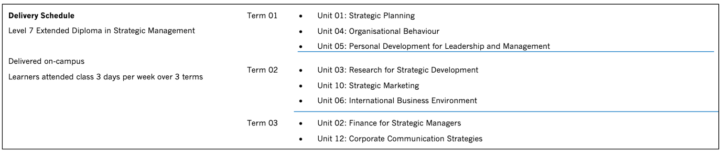
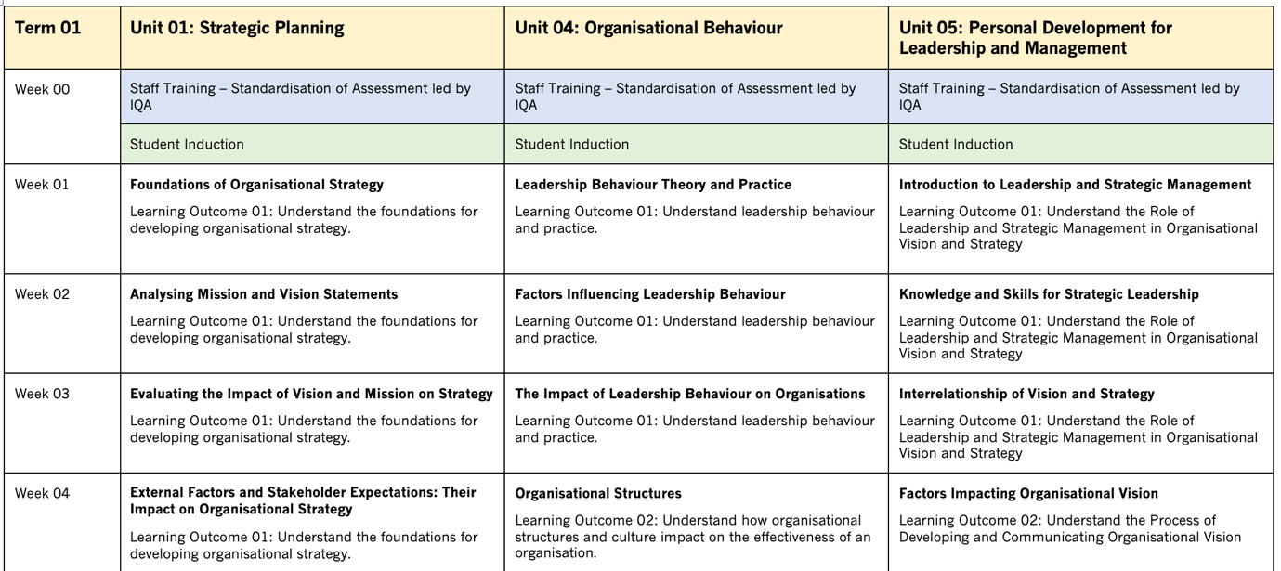
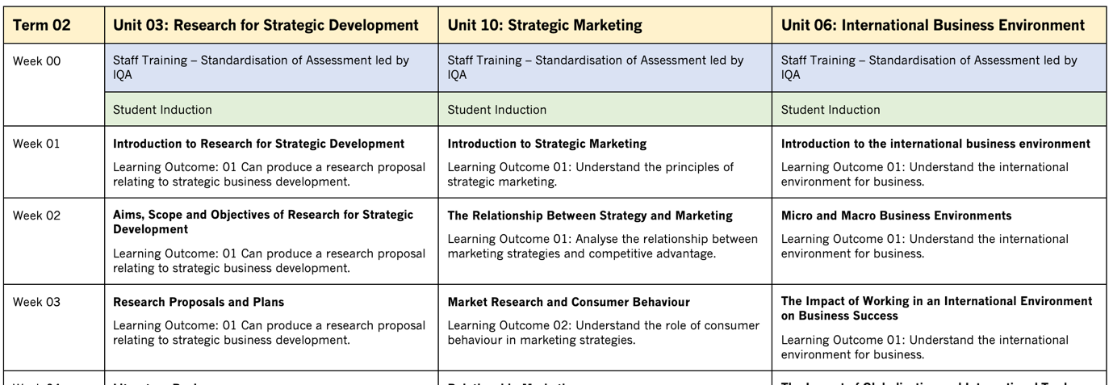

Appendix 2: Suggested Template for the Scheme of Work.
